Project Development Phase
Model Performance Test

Date | 21 February 2025
Team ID | PNT2022TMIDxxxxxx
Project Name | Import Data using Transform Maps (Spreadsheet)
Maximum Marks

Model Performance Testing:
Project team shall fill the following information in model performance testing template.
S.No. | Parameter | Values | Screenshot
1. | Model Summary | ServiceNow data-import automation for student records: a spreadsheet (.xlsx) with 5 records (Student ID, Student Name, Department, Email, Year) is loaded into the import set table u_student_import and moved to the target table u_student_information using the Transform Map "Student Information".  Note: If the source fields match the target fields correctly, records are created; otherwise the transform shows errors. | 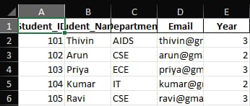
2. | Table Structure (Target Table) | Custom table "Student Information" [u_student_information] created with columns: Student ID (Integer), Student Name (String), Department (String), Email (String), Year (Integer), plus system fields (Sys ID, Created, Created by, Updated, Updated by, Updates). | 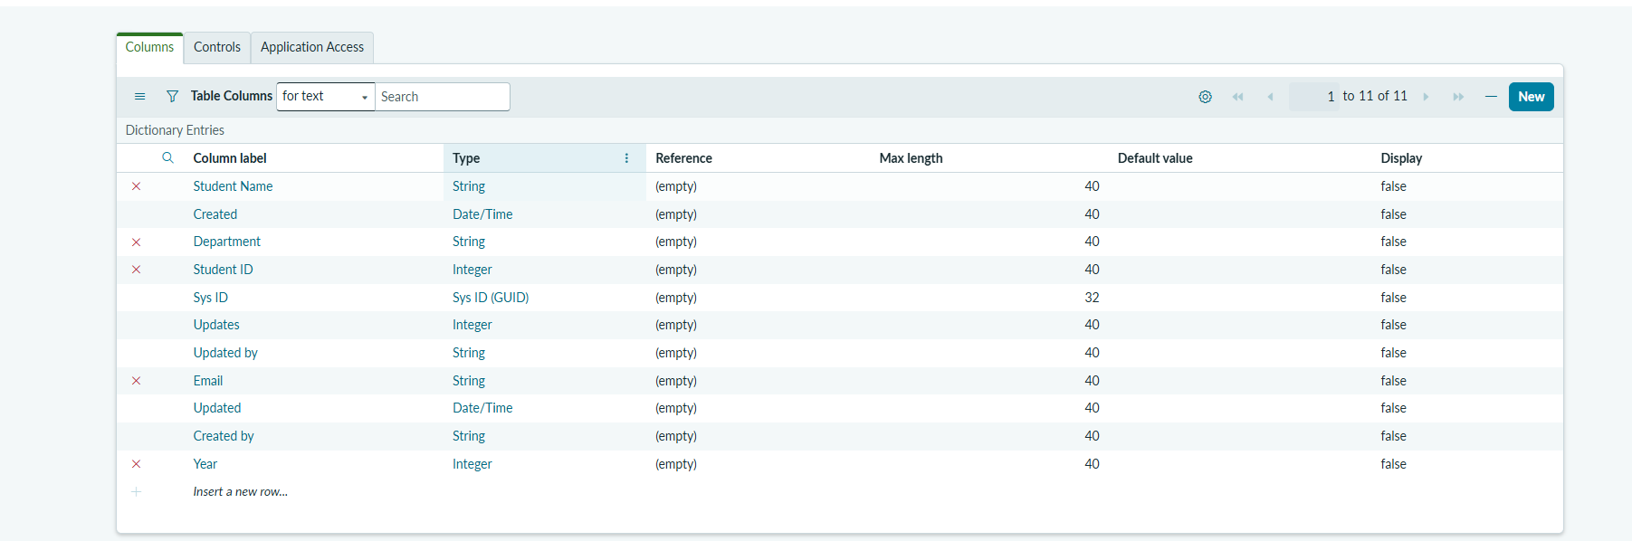
3. | Import Result (Accuracy) | Transform state: Complete  Total: 5 | Inserts: 5 | Updates: 0 | Ignored: 0 | Skipped: 0 | Errors: 0  Import success rate: 100% (5 of 5 records inserted)  Run time: 1 second
4. | Report | Report "Student Information" on table u_student_information, type Pie chart, Group by: Email, Aggregation: Count. Result: 5 slices of 20% each, confirming all 5 unique records were imported. | 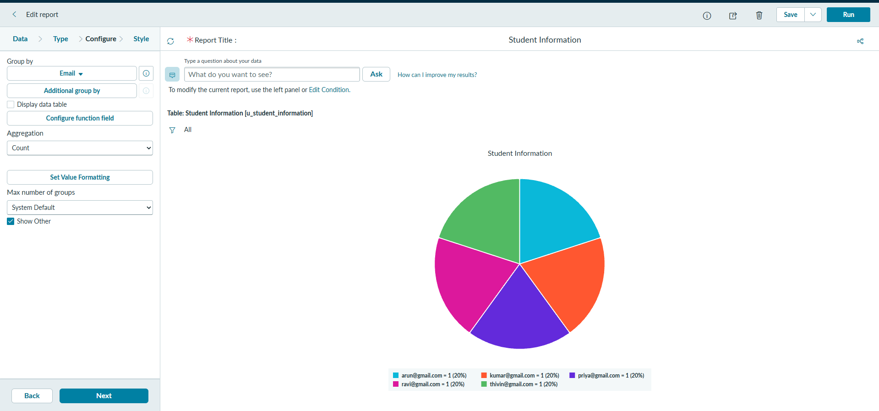
5. | Dashboard | "Student Information Dashboard" with a single-score widget showing total records = 5 and a line chart of records by date (Sep 27). | 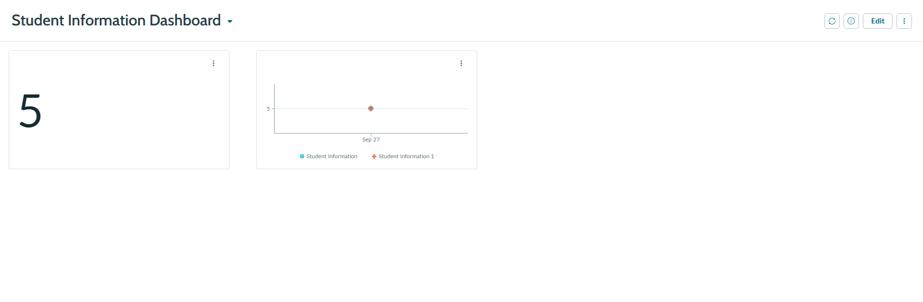

Output Screenshots:
Figure 1: Student spreadsheet (source data – 5 records)
Figure 2: Student Information table columns (Create Table)
Figure 3: Transform History – run results (5 inserts, 0 errors)
Figure 4: Student Information report (pie chart grouped by Email)
Figure 5: Student Information Dashboard

